**Google Play Store Data Analysis**

**Objective**

The objective of this project is to analyze the Google Play Store dataset to uncover insights about app ratings, installs, reviews, and sentiment distribution. The analysis uses Python libraries for data manipulation and visualization to provide actionable recommendations for app developers and marketers.

**Data Preparation**

**1. Data Import**

* Datasets googleplaystore.csv and googleplaystore_user_reviews.csv were imported into Python using pandas.
* Key fields such as Size, Installs, Price, and Rating were cleaned and converted to appropriate data types.
* Missing values in the Rating column were handled by removing rows with null values to ensure accurate analysis.

**2. Preprocessing Steps**

* **Size Conversion**: Converted app sizes from MB and KB to numeric values in MB.
* **Sentiment Analysis**: Used the VADER sentiment analyzer to classify user reviews as Positive, Neutral, or Negative.
* **Installs and Price**: Removed unnecessary symbols (e.g., "+", ",", "$") and converted fields to numeric values.

**Visualizations and Analysis**

**1. Top 10 Apps by Rating**

* Identified the apps with the highest user ratings.
* A bar chart displayed the ratings of the top 10 apps.
* **Key Insight**: Apps with niche functionalities tend to have higher user satisfaction.

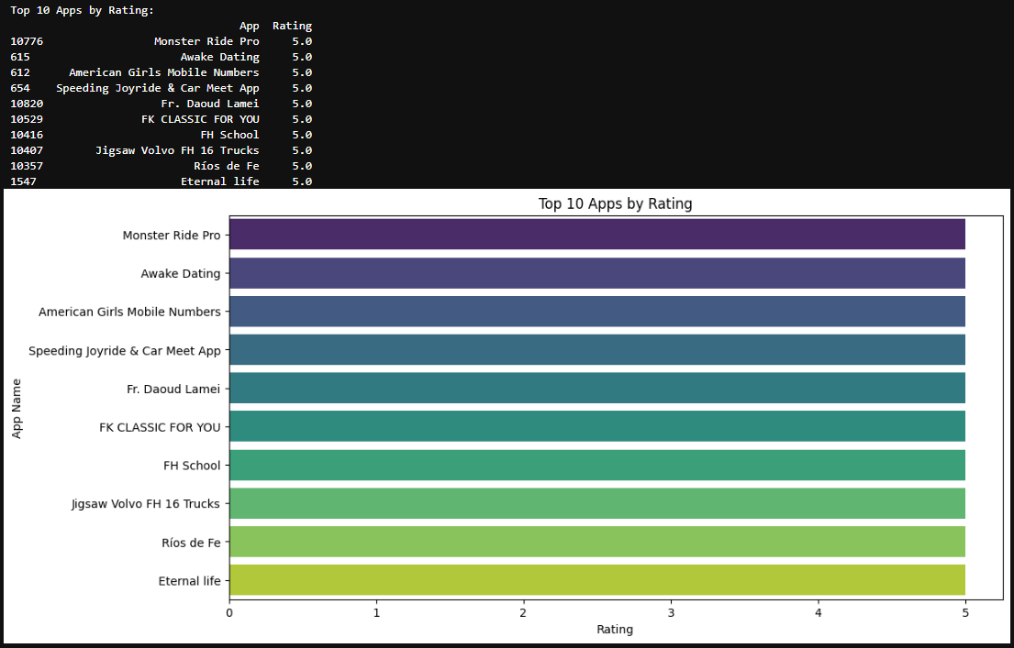

**2. Category-Wise Distribution of Apps**

* Counted apps in each category and visualized the distribution using a bar chart.
* **Key Insight**: Categories like Family and Game had the highest number of apps, indicating market saturation in these segments.

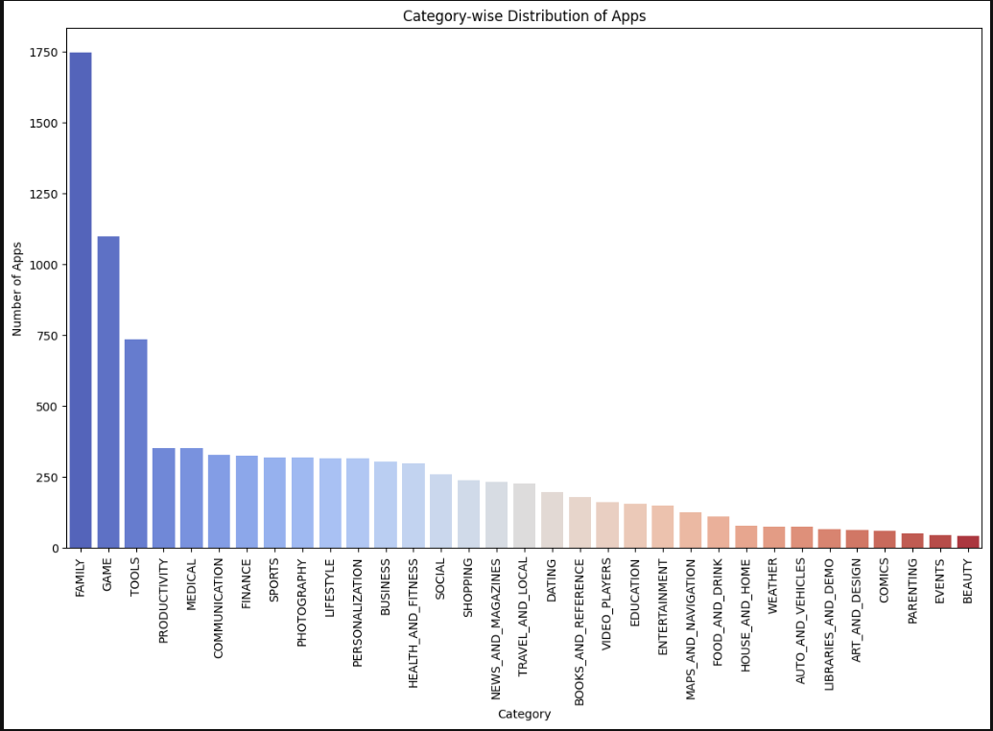

**3. Sentiment Analysis on User Reviews**

* Analyzed user sentiments and classified reviews into Positive, Neutral, or Negative.
* A bar chart displayed the distribution of sentiments.
* **Key Insight**: Positive sentiments dominated, highlighting overall user satisfaction, with significant improvement opportunities from Neutral and Negative feedback.

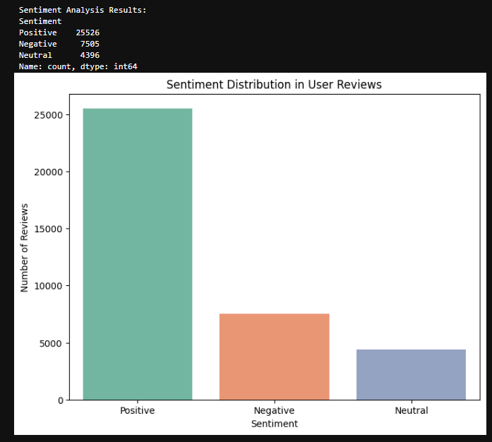

**4. Correlation Analysis**

* Investigated the relationship between app size, number of reviews, and ratings.
* A heatmap was created to visualize correlations.
* **Key Insight**: Higher review counts correlated moderately with higher ratings, suggesting user engagement as a factor.

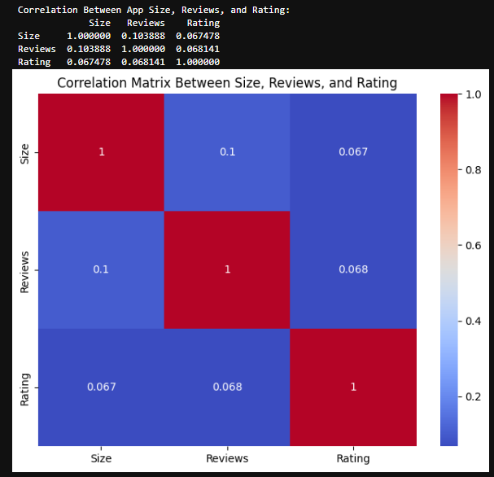

**5. Top Categories by Average Rating**

* Calculated the average rating for each category and visualized it using a bar chart.
* **Key Insight**: Categories like Health & Fitness and Education consistently received high user ratings.

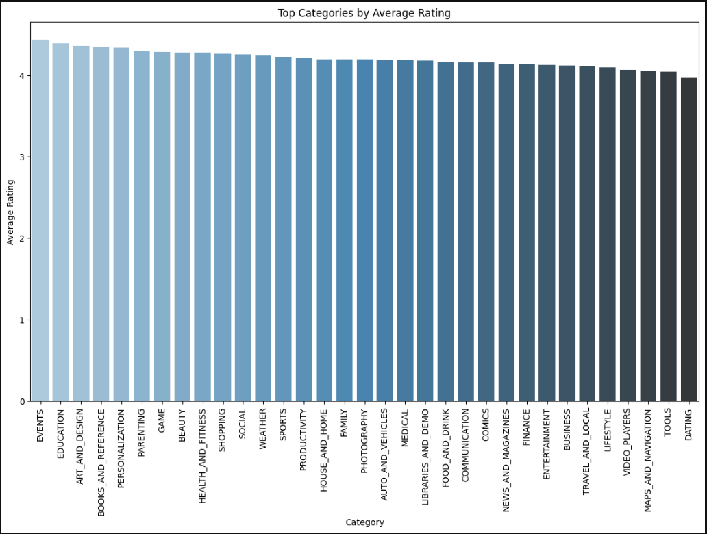

**6. Distribution of App Ratings**

* Visualized the distribution of ratings across all apps using a histogram.
* **Key Insight**: Most apps were rated between 4.0 and 4.5, indicating a generally favorable user perception.

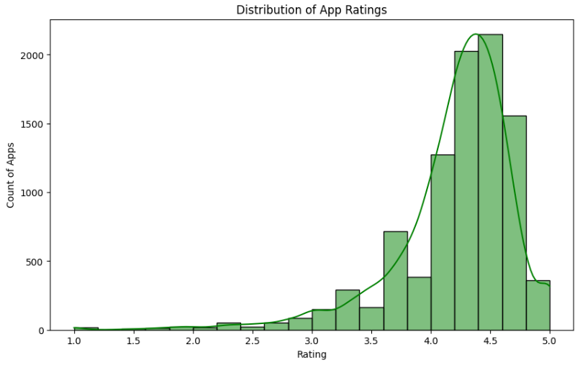

**7. Top 10 Most Reviewed Apps**

* Identified apps with the highest number of user reviews and visualized them using a bar chart.
* **Key Insight**: Popular apps like social media platforms and utility apps had significantly higher engagement.

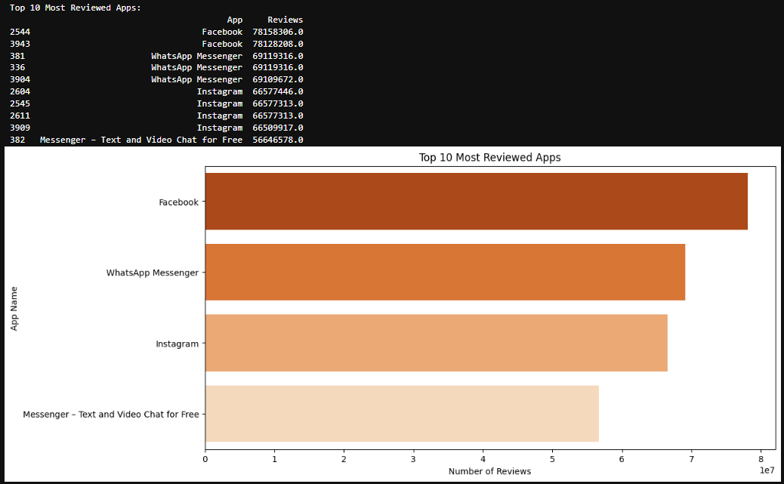

**8. Installs vs. Ratings**

* A scatter plot visualized the relationship between the number of installs and ratings.
* **Key Insight**: High installs often corresponded to average ratings, suggesting that mass adoption doesn't always equate to user satisfaction.

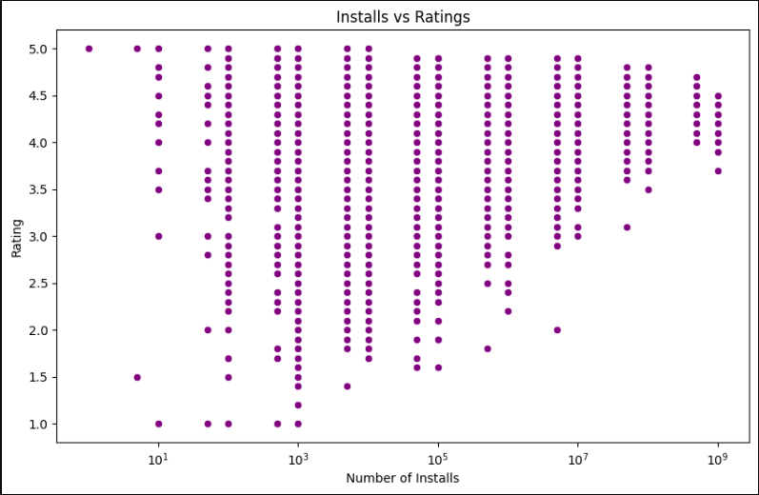

**9. Free vs. Paid Apps Analysis**

* Compared average ratings and reviews for free and paid apps using bar charts.
* **Key Insight**: Free apps had more installs and reviews, but paid apps often received higher average ratings.

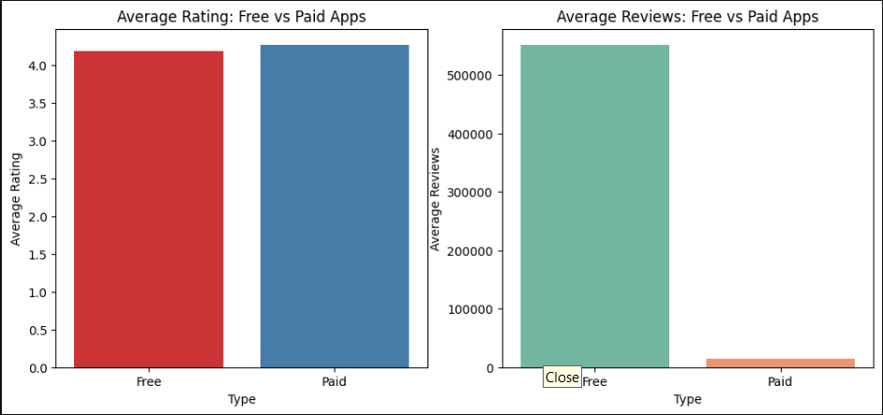

**10. Sentiment Distribution by Category**

* Grouped sentiments by category and visualized them using a stacked bar chart.
* **Key Insight**: Categories like Education and Entertainment had the highest percentage of positive reviews.

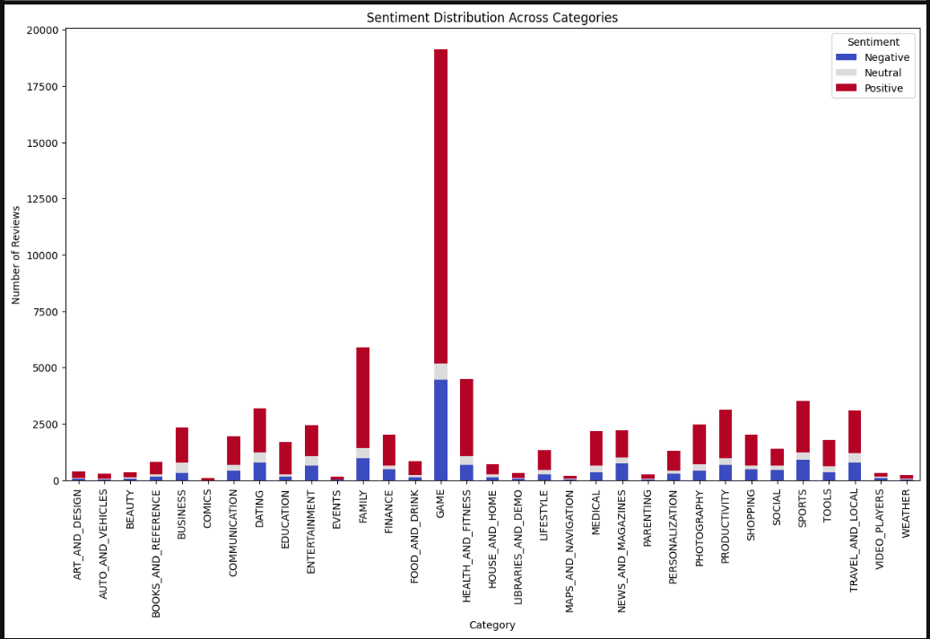

**11. Content Rating Distribution**

* Analyzed the distribution of apps by content rating (e.g., Everyone, Teen, Mature 17+).
* **Key Insight**: Most apps were rated for Everyone, emphasizing broad market targeting.

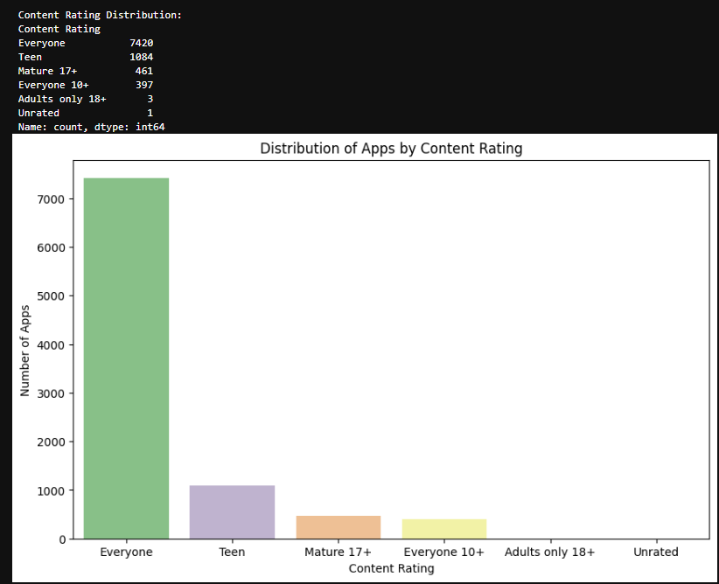

**12. Free vs. Paid Apps per Category**

* Analyzed the proportion of free and paid apps across categories.
* **Key Insight**: Categories like Tools and Business had a higher proportion of paid apps compared to Family and Game.

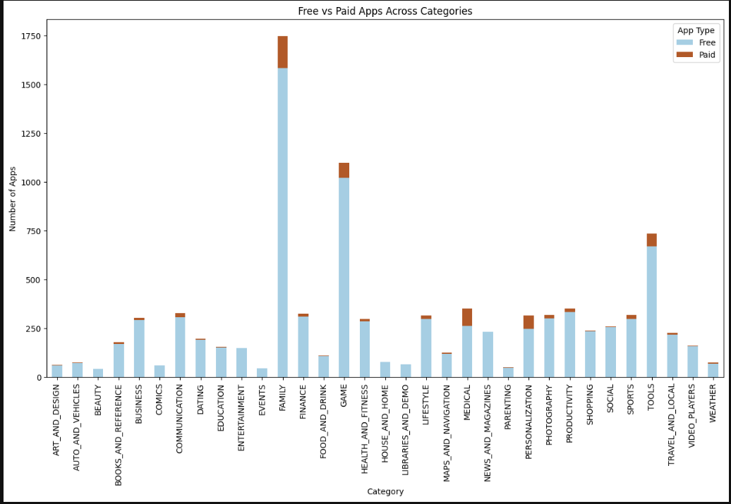

**13. Top 10 Apps by Installs**

* Identified the most installed apps and visualized them using a bar chart.
* **Key Insight**: Utility and social media apps dominated the install counts.4

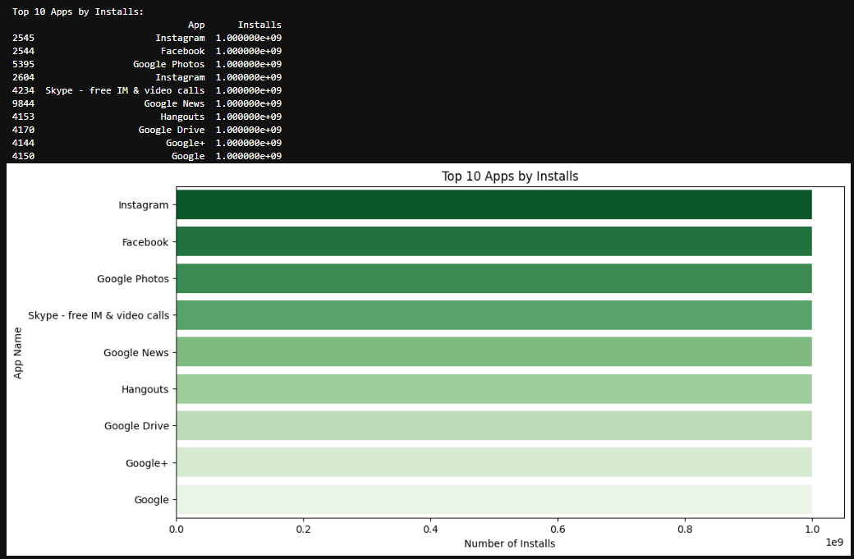

**Insights and Key Findings**

**Category Performance**

* **High-Performing Categories**: Health & Fitness, Education, and Entertainment consistently scored higher in user satisfaction.
* **Saturated Categories**: Family and Game categories had the most apps, suggesting intense competition.

**Sentiment Trends**

* Positive reviews dominated across categories.
* Neutral and negative reviews provided specific areas for improvement in user experience.

**Cost and Engagement**

* Smaller apps generally performed better in terms of user ratings.
* Free apps drove higher engagement but lower revenue potential.

**Recommendations**

**For Developers**

1. Focus on high-performing categories like Health & Fitness and Education.
2. Optimize app size to improve performance and user satisfaction.

**For Marketers**

1. Highlight positive reviews in advertising to boost installs.
2. Experiment with freemium models in saturated categories.

**For Product Teams**

1. Address issues highlighted in Neutral and Negative reviews.
2. Use sentiment analysis to prioritize feature enhancements.

**Conclusion**

This analysis of the Google Play Store dataset provided valuable insights into app performance, user sentiment, and market trends. By leveraging these findings, app developers and marketers can make data-driven decisions to enhance their products and strategies.